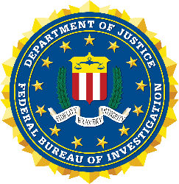

FBI LOUISVILLE
VIRTUAL RESUME AND INTERVIEW COURSE
REGISTRATION FORM

This course will discuss resume and interview tips in preparation for FBI Honors Internship Program Summer 2025. THE DEADLINE TO SUBMIT THIS FORM IS COB FRIDAY, FEBRUARY 2ND. Once you submit this form with a session selection, you will receive a Microsoft Teams link and further information closer to the date of the session. The HIP application can be found on FBIJobs.gov from February 12, 2024, until March 1, 2024. Please submit this form and direct any questions regarding this course to LouisvilleApplicants@fbi.gov.

- First Name: _______________________________________
- Last Name: _______________________________________
- Email Address: _____________________________________
- What University are you currently attending? ___________________________________________
- What year in school are you currently? (circle, check, or highlight which one)
  - Freshman
  - Sophomore
  - Junior
  - Senior
  - Attending graduate school
- What is your expected graduation date? _______________________________________________
- Will you be returning to school in Fall 2025?
  - Yes
  - No
  - Unsure at this time
- What is your current major? _________________________________________________________
- Which session would you like to attend? (circle, check, or highlight which one)
  - February 7, 2024 at 10:00 AM – 11:00 AM EST
  - February 7, 2024 at 1:00 PM – 2:00 PM EST
- How did you hear about this course? (circle, check, or highlight which one)
  - FBI emailed you
  - Current FBI employee
  - From your university
  - Other: ____________

